**Xception code**

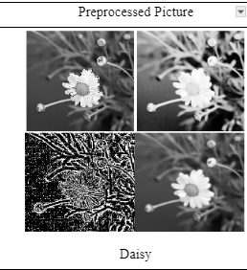

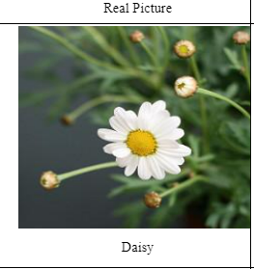

[Code based on 3669 Raw images](https://drive.google.com/file/d/1zfWfRhWfTPK9Kw2zXtKTb1O-Jcp4TFgm/view?usp=sharing) [Code based on14676 processed images](https://drive.google.com/file/d/11V8_odCKsgVarZoEzJPnXaK6cqCPIFUu/view?usp=sharing)